California State University Fullerton

CPSC 462



Object Oriented Software Design

Design Model

for the

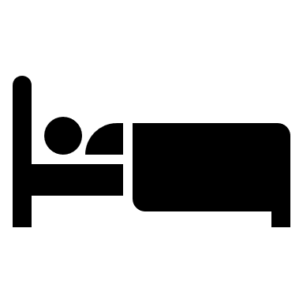

Hotel Room Reservation

System

|  |
| --- |
| **Allen Rivas** |
| Chief Technical Officer (CTO) |
| [allen.rrivas30@csu.fullerton.edu](mailto:allen.rrivas30@csu.fullerton.edu) |

Revision History:

| Version | Date | Summary of Changes | Author |
| --- | --- | --- | --- |
| 1.1 | April 27, 2021 | * Initial Release. Provided an updated version of the static view and dynamic view, which were built of the past diagrams that were made in Interception Phase. | Allen Rivas |
| 1.2 | May 16, 2021 | * Changes have been made to the Static View and all Software Sequence Diagrams . | Allen Rivas |

Table of Contents

1 Static View 1

1.1 Hotel Reservation System 1

1.1.1 Software Class Diagram 1

1.1.2 Description 1

2 Dynamic View 2

2.1 Login Sequence of Execution 2

2.1.1 Software Interaction Diagram 2

2.1.2 Description 2

2.1.3 SSD Traceability 2

2.2 Get List of Rooms Sequence of Execution 3

2.2.1 Software Interaction Diagram 3

2.2.2 Description 3

2.2.3 SSD Traceability 4

2.3 Get List of Services Sequence of Execution 4

2.3.1 Software Interaction Diagram 4

2.3.2 Description 4

2.3.3 SSD Traceability 4

2.4 Make Reservation Sequence of Execution 5

2.4.1 Software Interaction Diagram 5

2.4.2 Description 5

2.4.3 SSD Traceability 5

2.5 Make Payement Sequence of Execution 6

2.4.1 Software Interaction Diagram 6

2.4.2 Description 6

2.4.3 SSD Traceability 6

2.6 Get Reservation Sequence of Execution 7

2.4.1 Software Interaction Diagram 7

2.4.2 Description 7

2.4.3 SSD Traceability 7

2.7 Get Room Number Sequence of Execution 8

2.4.1 Software Interaction Diagram 8

2.4.2 Description 8

2.4.3 SSD Traceability 8

2.8 Get Room Key Sequence of Execution 9

2.4.1 Software Interaction Diagram 9

2.4.2 Description 9

2.4.3 SSD Traceability 9

# Static View

## Hotel Reservation System

### Software Class Diagram

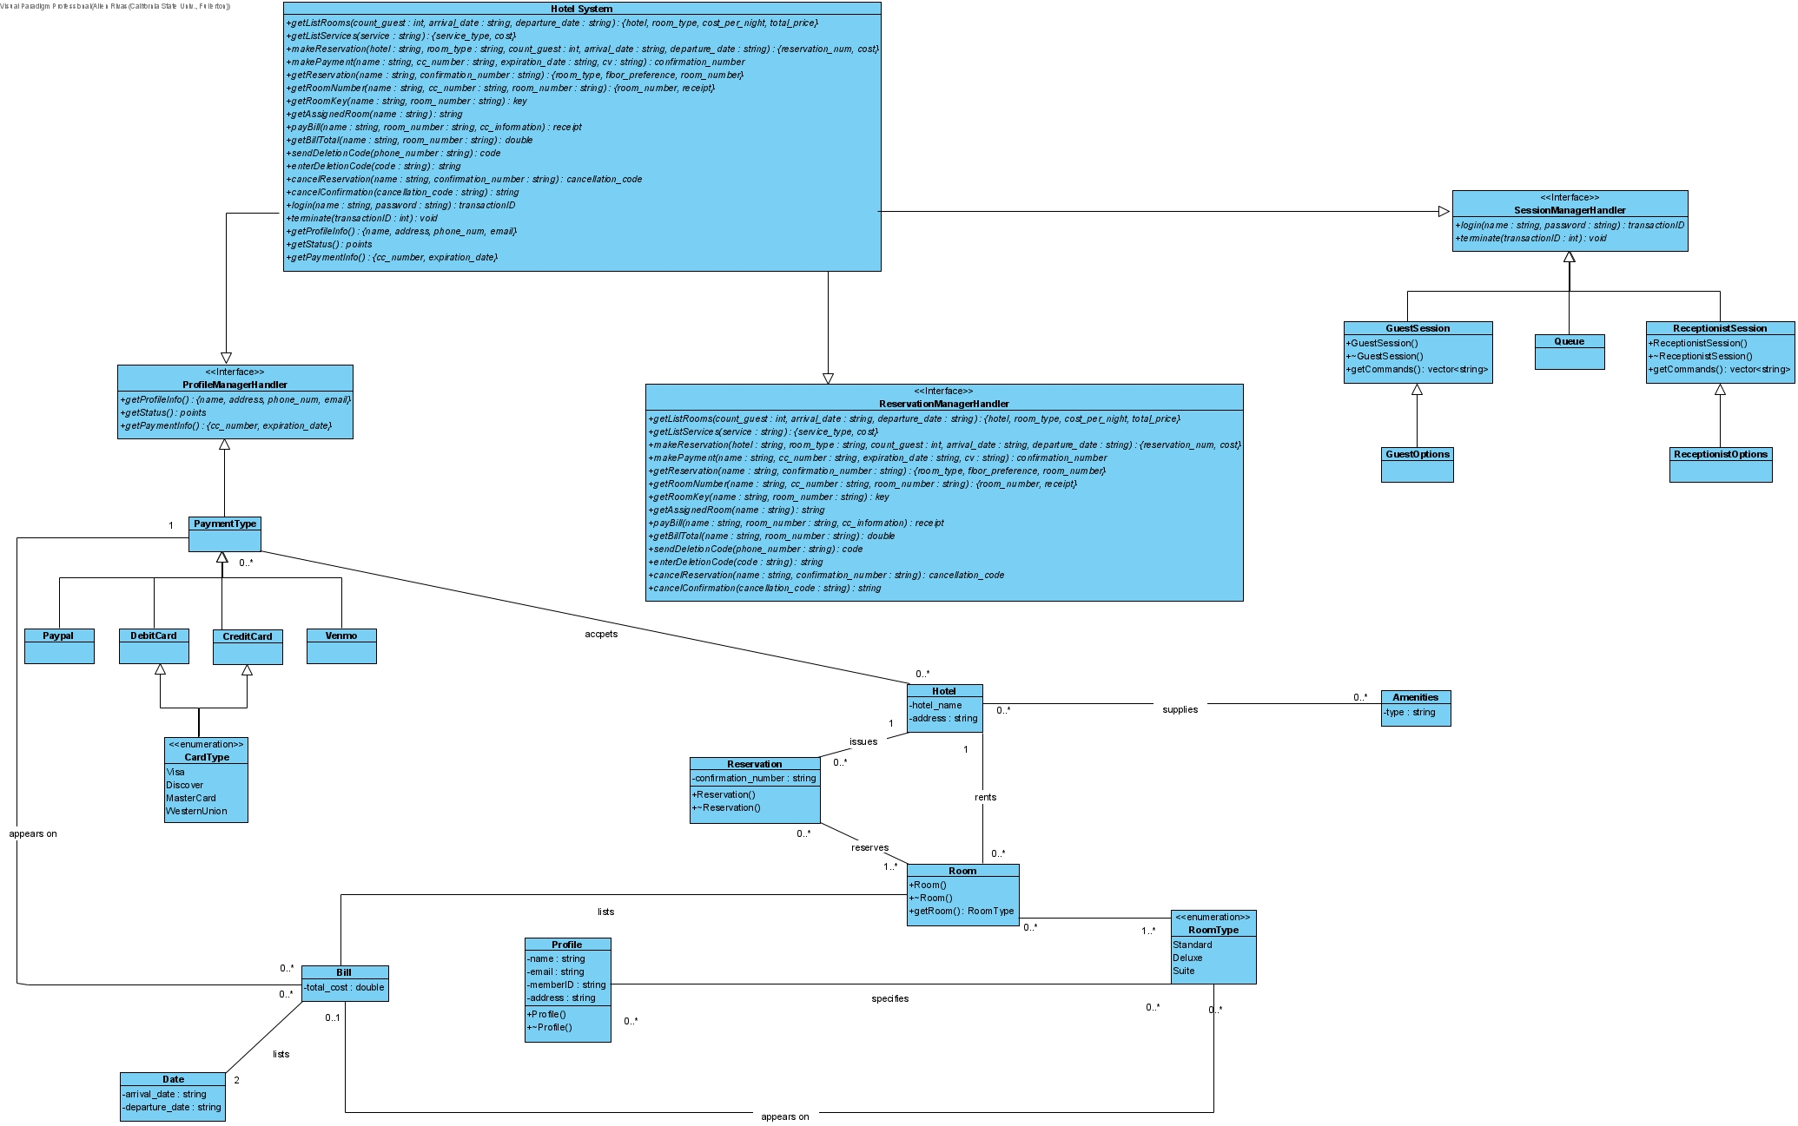

### Description

In this software class diagram, it is noticeable that the three sub packages from the domain layer have been included here as objects that all inherit from the hotel room reservation system. If we follow the diagram from left to right starting from the ProfileManagerHandler, there are two objects that are inherit it. They are PaymentType, which is inherited by the different ways that are used as a form of payment (Credit, Debit, PayPal or Venmo). The other component is Profile which is the carries the information about the specific profile. Bill which inherits from the Profile, provides the total cost of whatever the profile contains. Date inherits from the Bill which provides the arrival and departure dates for the bill. Onto the ReservationManagerHandler, which is inherited by three different components which are Reservation, RoomType, and Amenities. Reservation provides the confirmation number of the reservation. RoomType is an enumerator which list the different types of rooms. Amenities provide the type of amenity that is requested. Room component inherits from RoomType and Floor provides the floor in which is searched for. In the SessionManagerHandler, it is inherited by three components which are GuestSession, ReceptionistSession, and Queue. GuestSession is inherited by the GuestOptions, in here it’s the commands made the guest on whole long they last, and it is the same for the ReceptionistSession. In Queue, it estimates suppose to estimate how long the user waits for the session login.

# Dynamic View

## Login Sequence of Execution

### Software Interaction Diagram

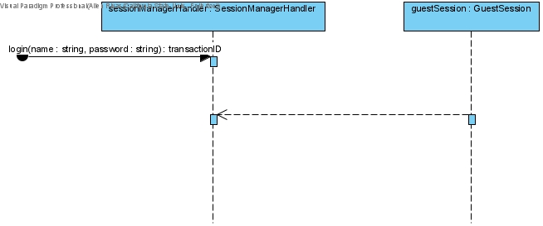

### Description

For each of these diagrams we do not care what actor launches the sequence, since there is none above in this diagram and the other. First, the user logs into their account, which is executed from the guestSession. Finally, they terminate the session by executing terminate which ends their session.

### SSD Traceability

This request message is made in the Make Reservation SSD. So, the executions are going to be made in the sessionManagerHandler, where the user logs in, where they can make commands that allow them to terminate their session.

## Get List of Rooms Sequence of Execution

### Software Interaction Diagram

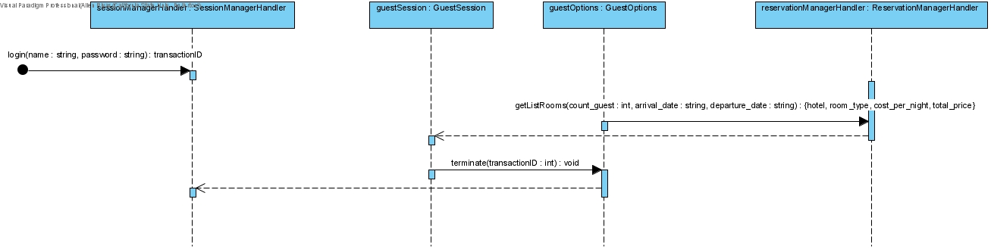

### Description

Sequence starts at sessionManagerHandler where login is executed providing login and password. Then a getListRooms is executed providing amount of guests, arrival, and departure date, where it returns to the sessionManagerHandler, a hotel, room type, cost per night, and total price. Finally, terminate is executed and the current login session ends.

### SSD Traceability

This request message is made in the Make Reservation SSD. The execution starts in the sessionManagerHandler where it is also identified in the static view which inherits from the hotel system. guestSession is in motion, the execution that happens next is getListRooms which is found in the reservationManagerHandler. The guestSession then executes terminate which is inherited from the sessionManagerHandler.

## Get List of Services Sequence of Execution

### Software Interaction Diagram

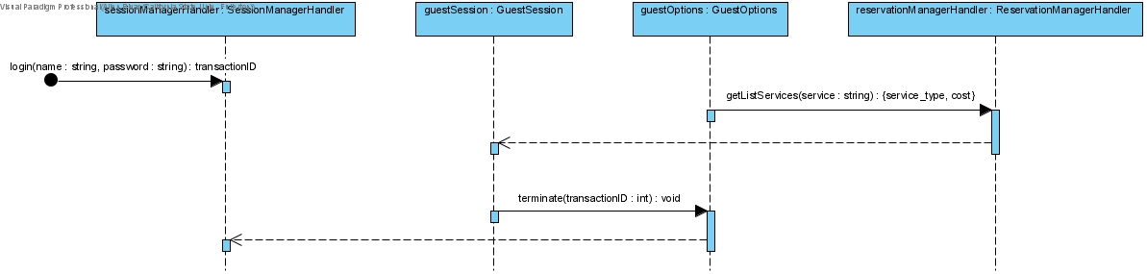

### Description

Sequence starts at sessionManagerHandler where login is executed providing login and password. Then a getListRooms is executed providing amount of guests, arrival, and departure date, where it returns to the sessionManagerHandler, a hotel, room type, cost per night, and total price. Then a getListServices is executed, where it returns to the sessionManagerHandler, a service of type string. Finally, terminate is executed and the current login session ends.

### SSD Traceability

This request message is made in the Make Reservation SSD. The execution starts in the sessionManagerHandler where it is also identified in the static view which inherits from the hotel system. guestSession is in motion, the execution that happens next is getListRooms which is found in the reservationManagerHandler. The execution that happens next is getListServices which is found in the reservationManagerHandler. The guestSession then executes terminate which is inherited from the sessionManagerHandler.

## Make Reservation Sequence of Execution

### Software Interaction Diagram

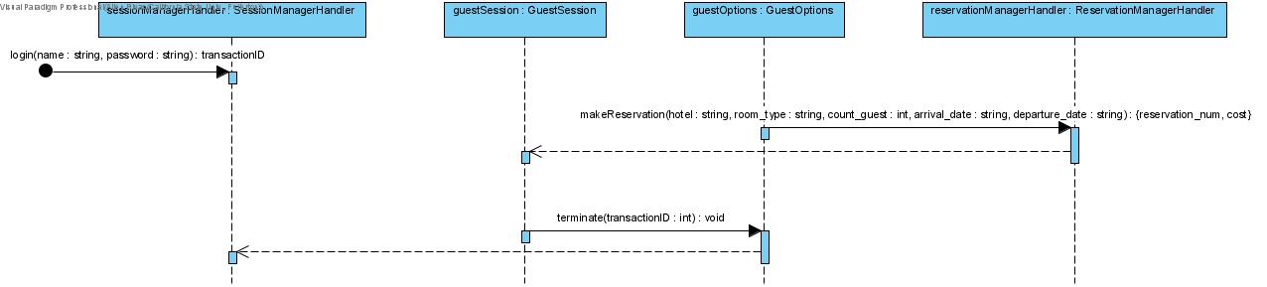

### Description

Sequence starts at sessionManagerHandler where login is executed providing login and password. Then a getListRooms is executed providing amount of guests, arrival, and departure date, where it returns to the sessionManagerHandler, a hotel, room type, cost per night, and total price. Then a getListServices is executed, where it returns to the sessionManagerHandler, a service of type string. Then a makeReservation is executed providing hotel, room type, amount of guest, arrival, and departure date, where it returns to the SessionManagerHandler, the reservation number and cost. Finally, terminate is executed and the current login session ends.

### SSD Traceability

This request message is made in the Make Reservation SSD. The execution starts in the sessionManagerHandler where it is also identified in the static view which inherits from the hotel system. guestSession is in motion, the execution that happens next is getListRooms which is found in the reservationManagerHandler. The execution that happens next is getListServices which is found in the reservationManagerHandler. The execution that happens next is makeReservation which is found in the reservationManagerHandler. The guestSession then executes terminate which is inherited from the sessionManagerHandler.

## Make Payment Sequence of Execution

### Software Interaction Diagram

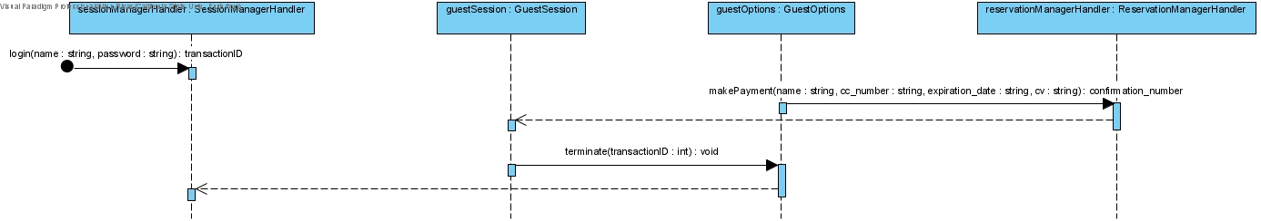

### Description

Sequence starts at sessionManagerHandler where login is executed providing login and password. Then a getListRooms is executed providing amount of guests, arrival, and departure date, where it returns to the sessionManagerHandler, a hotel, room type, cost per night, and total price. Then a getListServices is executed, where it returns to the sessionManagerHandler, a service of type string. Then a makeReservation is executed providing hotel, room type, amount of guest, arrival, and departure date, where it returns to the SessionManagerHandler, the reservation number and cost. Then a makePayment is executed providing name, payment card number, payment card cv, where it returns to the SessionManagerHandler, a confirmation number. Finally, terminate is executed and the current login session ends.

### SSD Traceability

This request message is made in the Make Reservation SSD. The execution starts in the sessionManagerHandler where it is also identified in the static view which inherits from the hotel system. guestSession is in motion, the execution that happens next is getListRooms which is found in the reservationManagerHandler. The execution that happens next is getListServices which is found in the reservationManagerHandler. The execution that happens next is makeReservation which is found in the reservationManagerHandler. The execution that happens next is makePayment which is found in the reservationManagerHandler. The guestSession then executes terminate which is inherited from the sessionManagerHandler.

## Get Reservation Sequence of Execution

### Software Interaction Diagram

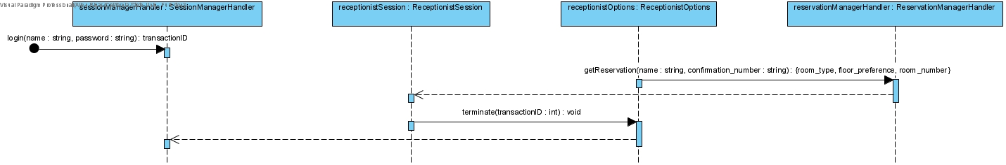

### Description

Sequence starts at sessionManagerHandler where login is executed providing login and password. Then a getReservation is executed providing name and confirmation number, where is returns to the sessionManagerhandler, a room type, floor preference, and room number. Finally, terminate is executed and the current login session ends.

### SSD Traceability

This request message is made in the Make Check In SSD. The execution starts in the sessionManagerHandler where it is also identified in the static view which inherits from the hotel system. receptionistSession is in motion, the execution that happen is getReservation which is found in the reservationManagerHandler. The receptionist Session then executes terminate which is inherited from the sessionManagerHandler.

## Get Room Number Sequence of Execution

### Software Interaction Diagram

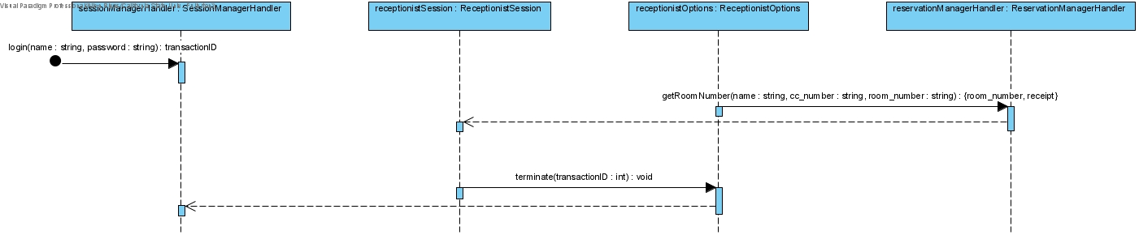

### Description

Sequence starts at sessionManagerHandler where login is executed providing login and password. Then a getReservation is executed providing name and confirmation number, where is returns to the sessionManagerhandler, a room type, floor preference, and room number. Then getRoomNumber is executed providing name, payment card number, and room number, where it returns to the sessionManagerHandler a room number and receipt. Finally, terminate is executed and the current login session ends.

### SSD Traceability

This request message is made in the Make Check In SSD. The execution starts in the sessionManagerHandler where it is also identified in the static view which inherits from the hotel system. receptionistSession is in motion, the execution that happen is getReservation which is found in the reservationManagerHandler. The execution that happens next is getRoomNumber which is found in the reservationManagerHandler. The receptionist Session then executes terminate which is inherited from the sessionManagerHandler.

## Get Room Key Sequence of Execution

### Software Interaction Diagram

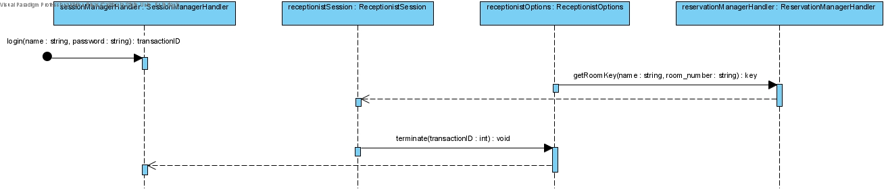

### Description

Sequence starts at sessionManagerHandler where login is executed providing login and password. Then a getReservation is executed providing name and confirmation number, where is returns to the sessionManagerhandler, a room type, floor preference, and room number. Then getRoomNumber is executed providing name, payment card number, and room number, where it returns to the sessionManagerHandler a room number and receipt. Then getRoomKey is executed providing name, and room number where it returns to the sessionManagerHandler a key. Finally, terminate is executed and the current login session ends.

### SSD Traceability

This request message is made in the Make Check In SSD. The execution starts in the sessionManagerHandler where it is also identified in the static view which inherits from the hotel system. receptionistSession is in motion, the execution that happen is getReservation which is found in the reservationManagerHandler. The execution that happens next is getRoomNumber which is found in the reservationManagerHandler. The execution that happens next is getRoomKey which is found in the reservatioManagerHandler. The receptionist Session then executes terminate which is inherited from the sessionManagerHandler.